DRAFT CONDITIONS OF CONSENT
Da103/2021

PART 1 - GENERAL CONDITIONS
The following conditions have been applied to ensure that the use of the land and /or the building is carried out in such a manner that it is consistent with the aims and objectives of the planning instrument affecting the land.

For the purpose of these conditions, the term ‘applicant’ means any person who has the authority to act on the development consent.

- Except where otherwise required or permitted by conditions of development consent, the development shall be carried out generally in accordance with the information submitted in support of the development application and the following stamped approved development drawings, including any notations or amendments marked by Council in red.
Title/ Description | Document reference | Document Dated | Prepared by
Environmental Impact Statement | 1938 | July 2021 | Laterals Planning
Air Quality Impact Assessment | 610.30252-R01 | March 2021 | SLR Consulting Australia Pty Ltd
Aboriginal Cultural Heritage Due Diligence Assessment | Revision D1 | 5 April 2021 | Past Traces Heritage Consultants
Environmental Noise Impact Assessment | 2006003E-R | 12 July 2021 | Harwood Acoustics Acoustical Consulting
Soil & Water Assessment | Revision D | 5 April 2022 | Strategic Environmental & Engineering Consulting
Traffic and Parking Impact Report | N206370A | September 2020 | Motion Traffic Engineers
Biodiversity Assessment | 140104_1 | 19 March 2021 | Macrozamia Environmental Consulting
Existing Site Plan Topographic Detail | 1938 - Sheet 1 | 14 July 2021 | Laterals Engineering & Management Laterals Planning
Existing Site Plan Aerial Photograph | 1938 – Sheet 2 | 14 July 2021 | Laterals Engineering & Management Laterals Planning
Proposed Quarry Extension Topographic Detail | 1938 – Sheet 3 | 14 July 2021 | Laterals Engineering & Management Laterals Planning
Proposed Quarry Extension Aerial Photograph | 1938 – Sheet 4 | 14 July 2021 | Laterals Engineering & Management Laterals Planning
Engineering Details | Sheets 1 – 4 and 10 – 12 Revision C | 4 June 2021 | Regional Engineering Services
Engineering Details | Sheets 5 – 9 Revision B | 12 May 2021 | Regional Engineering Services
Cross Sections | 1938  Sheets 1 - 3 | 14 July 2021 | Laterals Engineering & Management Laterals Planning

Reason: Development is undertaken in accordance with this consent & is used for the approved purpose only.

- For the purpose of ensuring the compliance with the terms of the approval, an approved copy of the plan and this Consent shall be kept on site at all times.
Reason: Relevant documentation is available for perusal on site by a council officer, for compliance check.

- The maximum number of heavy vehicle movements exporting material extracted from the quarry operations shall not exceed five (5) per day in accordance with the Draft Operational Environmental Management Plan.
Reason: Development is undertaken in accordance with this consent & is used for the approved purpose only

- No more than 16,000 tonnes per annum shall be extracted and transported from the development. The operator shall furnish Council with a report on a quarterly basis that details the total quantities of material removed from the site for that period, including but not limited to the respective dates and times.
Reason: Development is undertaken in accordance with this consent & is used for the approved purpose only

- Quarry activities including but not limited to the extraction and truck movements associated with the development shall only occur between 7am - 5pm Monday to Friday, and 7.00am to 1.00pm on Saturdays. There shall be no quarry activities on Sunday and Public Holidays.
Reason: Development is undertaken in accordance with this consent & is used for the approved purpose only

- No materials are to be stored or quarry operations activities undertaken on public or adjoining land without prior written approval from Council.
Reason: To prevent unnecessary disturbance to public land.

PART 2 - PRIOR TO COMMENCEMENT OF OPERATIONS UNDER THIS CONSENT
The following conditions of consent have been imposed to ensure that the administration and amenities relating to the proposed development comply with all relevant requirements. These conditions are to be complied with prior to the commencement of any work on site associated with this approval.

(PLEASE NOTE: ALSO REFER TO PART 4 - AGENCIES CONDITIONS)

- Prior to the commencement of operations under this consent an Operational Environmental Management Plan shall be submitted with and approved by the Upper Lachlan Shire Council. The Operational Environmental Management Plan shall be the mechanism which incorporates all applicable documentation, reports and associated recommendations that are required to be adhered to for the life of the project.

- Prior to undertaking any site establishment works;
- A registered land surveyor is to be engaged to mark out the boundaries of the approved limits of extraction; and
- These boundaries are to be clearly marked at all times in a permanent manner that allows operating staff and inspecting officers to clearly identify those limits.
Reason: The site is managed in a safe manner.

- The site where works (and access) are proposed to be carried out shall be identified by a sign sited in a visually prominent position containing the following information;
- the development application number,
- name, address and telephone number of the principal certifying authority,
- name of the principal contractor (if any) and 24 hour contact telephone number, and
- a statement that “unauthorised entry to the work site is prohibited”.
Reason: To satisfy the provisions of Clause 136B and 227A of the Environmental Planning and Assessment Regulation 2000.

Prior to the commencement of operations under this consent and every subsequent five years for the duration of the operation of the quarry a ‘Vegetation and Rehabilitation Plan’ shall be submitted to and approved by the Upper Lachlan Shire Council for the quarry that provides long-term stability to the quarry site, the access road and immediate surrounds after the completion of operational phase.
The Vegetation and Rehabilitation Plan shall:
- provide an initial final concept depicting the proposed final landform including contours;
- provide for progressive rehabilitation of the site;
- provide for the delivery of the site following the completion of quarrying activities in a state that is compatible with likely future environmental or agricultural uses in accordance with the site’s zoning;
- incorporate the existing quarry site;
- detail plant species, location, method of planting and ongoing maintenance program. The plan shall include trees, shrub/bushes and grass species that are endemic to the region in which the quarry is situated; and
- detail the location of all plantings with the final outcome being to suitably screen the existing and proposed operations from adjoining boundaries including the Federal Highway.

The actions contained within the plans shall:
- be implemented progressively during the operation of the site;
- be monitored, maintained and managed as per the Plan; and
- all vegetation shall be maintained in perpetuity of the project and plants which die within the first three years of planting shall be replaced within 6 months.

Reason: To stabilise the site and manage potentially adverse water quality impacts in the post-operational phase of the development, to ensure a neutral or beneficial impact on water quality over the longer term.

- Prior to the commencement of operations under this consent for the quarry extension, an indicative cost to rehabilitate the quarry shall be provided to the Upper Lachlan Shire Council by a suitably qualified and registered quantity surveyor and be in accordance with the approved Vegetation and Rehabilitation Plan.

Reason: In accordance with clause 8.5 of the Upper Lachlan Development Control Plan 2010.

- Prior to the commencement of operations under this consent for the quarry extension a detailed cost report for each individual rehabilitation stage of the development shall be submitted to and approved by the Upper Lachlan Shire Council. The cost report shall be prepared by a suitably qualified and registered quantity surveyor and be in accordance with the approved Vegetation and Rehabilitation Plan.

The cost report shall be reviewed and updated prior to the rehabilitation of all subsequent stages of the operation.

When each individual rehabilitation stage of the development is reached a bank guarantee or performance bond to the value of the rehabilitation works associated with that stage of the development shall be lodged in favour of Upper Lachlan Shire Council prior to commencement of work under this consent. The guarantee / bond shall be refunded upon completion of all works associated with the rehabilitation of each individual stage of the development.

Reason: In accordance with clause 8.5 of the Upper Lachlan Development Control Plan 2010.

- Within 12 months of the date of commencement of development to which this consent applies, or within another timeframe agreed by the Council, the Applicant must surrender the existing development consent dated 6 September 2007 for a ‘Quarry’ [Development Approval No: 2002/0156/DA] in accordance with the EP&A Regulation. Upon the commencement of development to which this consent applies, and before the surrender of the existing development consent the conditions of this consent prevail to the extent of any inconsistency with the conditions of those consents or approvals.

Reason: To ensure clear delineation between the existing and proposed uses of the site.

- No works under this consent shall commence unless provision has been made for temporary toilet accommodation on the site of the work, which shall remain onsite and be serviced for the life of the quarry.

Reason: To ensure satisfactory sanitary facilities are made available for use by persons carrying out building, subdivision or demolition work.

- The operator of the quarry must ensure that they do not import weed material to the site or export weed material from the site. Prior to operations commencing under this consent the following actions will be undertaken to achieve this;
  - A weed management plan will be prepared and implemented to ensure the project does not increase the occurrence of weed species on the site or adjoining lands the plan will incorporate the following practices;
  - The site manager will ensure that procedures are in place to ensure plant and equipment entering the site are clean and free of mud, soil and vegetation material.

- The developer shall construct a vegetated amenity barrier along the northern and eastern edges of the extraction area to protect the site from possible flood inundation. The location and design of the amenity barrier shall be in accordance with the Soil and Water Assessment as prepared by SEEC and dated 5 April 2022.

Reason: To minimise the potential for impact on operations and water quality as a result of flood waters.

- The ‘main sump’ shall be constructed in accordance with the report as submitted by SEEC and dated 5 April 2022 prior to works commencing in the proposed new quarry.

Reason: To minimise any potential impact of the quarry operations on the water quality.

- The developer shall provide details and a design on how it is proposed to dissipate the energy associated with concentrated stormwater flows generated as a result of the bund /s constructed around the perimeter of the quarry. These designs shall be submitted to Council for approval and be installed prior to the commencement of operations under this consent.

Reason: To minimise any potential impact of the quarry operations on the water quality and erosion.

PART 3 - DURING CONSTRUCTION
The following conditions of consent have been imposed to ensure that the administration and amenities relating to the proposed development comply with all relevant requirements. These conditions are to be complied with during the construction of the development on site.

- If any Aboriginal object is uncovered or identified in the carrying out of operations, the developer shall immediately cease work in the vicinity of the Aboriginal object and contact the NSW Office of Environment and Heritage and the relevant Local Aboriginal Land Council to arrange their assessment.
Reason: To ensure objects discovered during construction are protected and notified in accordance with the Due Diligence Code of Practice for the Protection of Aboriginal Objects in New South Wales.
Reason: To ensure compliance with NSW legislative requirements.
- If any human remains are discovered during any construction work and/or operations, then all activity in the vicinity of the find must cease. As a first step the local police must be notified, followed by NSW Heritage and advice sought on appropriate next actions. No work can continue on the site until cleared with police and NSW Heritage.
Reason: To ensure objects discovered during construction are protected and notified in accordance with the Due Diligence Code of Practice for the Protection of Aboriginal Objects in New South Wales.
Reason: To ensure compliance with NSW legislative requirements.
- All hazardous materials stored onsite, including but not limited to diesel fuel, other hydrocarbons, along with lubricating oils and greases, are to be stored separately onsite within bunded areas or storage areas with no other flammable materials. Where stored on a utility, trailer or similar the storage container must be self-bunding or stored in self bunding containers.
Reason: To ensure for safe storage of potentially hazardous materials through operations

- All damage caused to public property during the quarry operations and associated activities must be repaired or reinstated within one (1) month of being advised by Council.
Reason: To ensure that all public property in the vicinity of the development is maintained in its pre-development condition.

- Surface water shall not be re-directed onto adjoining private land. Alterations to the surface contours must not impede or divert natural surface water run-off, so as to cause a nuisance to adjoining property owners or create an erosion or sediment problem.
Reason: Stormwater disposal does not impact on the neighbouring properties.
- The operation of the quarry and associated activities shall be undertaken in accordance with all respective requirements of SafeWork NSW.
Reason: To ensure compliance with NSW legislative requirements and for safety of workers and visitors.

PART 4 - AGENCY CONDITIONS – TRANSPORT FOR NSW LETTER DATED 16 SEPTEMBER 2021
- TfNSW General Terms of Approval
The approved quarry operations must be developed in accordance with the approved plans and the concurrence from TfNSW dated 08 February 2022. The General Terms of Approval detailed by TfNSW are set out in Attachment 1 to this Notice of Determination.

PART 5 – DURING OPERATION (ONGOING)

- All parking for visitors, staff or the like shall be retained on-site.
Reason: To comply with the description of the development as submitted with the application and for traffic safety.

- With respect to air quality the development does not result in a cumulative annual average level greater than 25 µg/m³ of PM₁₀ or 8 µg/m³ of PM_{2.5} for private dwellings.
Reason: To comply with legislative requirements.

- Ground vibration caused by the development shall not exceed—
    - 10 mm/sec (peak particle velocity) at any time, and
    - 5 mm/sec (peak particle velocity) for more than 5% of the total number of blasts over any period of 12 months, measured at any private dwelling or sensitive receiver.
Reason: To comply with legislative requirements.

- Any interference with an aquifer caused by the development shall not exceed the respective water table, water pressure and water quality requirements specified for item 1 in columns 2, 3 and 4 of Table 1 of the NSW Aquifer Interference Policy for each relevant water source listed in column 1 of that Table.
Note—
The taking of water from all water sources must be authorised by way of licences or exemptions under the relevant water legislation.

Reason: To comply with legislative requirements.

- The operator of the quarry must comply with section 120 of the Protection of the Environmental Operations Act 1997.

Reason: To comply with legislative requirements.

- All operations and activities at the premises must be carried out in a manner that will minimise the emission of dust from the premises.

Reason: To comply with legislative requirements.

- The drainage from all areas that will mobilise suspended solids when stormwater runs over these areas must be controlled and diverted through appropriate erosion and sediment control measures.

Reason: To comply with legislative requirements.

- The operator of the quarry must minimise the area of the site that is able to generate suspended material when water runs over it.

Reason: To comply with legislative requirements.

- Effective stormwater controls must be planned, designed, constructed, operated and maintained in accordance with the guideline “Managing Urban Stormwater – Soils and Construction, Volume 2B, Waste Landfill” DECC 2008, to be read and used in conjunction with Volume 1 “Managing Urban Stormwater: Soils and Construction” Landcom 2006.

Reason: To comply with legislative requirements.

- The operations must maximise the reuse of captured stormwater on the premises.

Reason: To comply with legislative requirements.

- Prior to the discharge of any waters from the sediment control dam/s the operator shall test for and monitor the concentration of total suspended particles. Where the concentration of total suspended particles exceeds the recommended standard for site discharge then such discharge shall not occur.

The monitoring of the waters from the sediment control dam/s shall be undertaken by an accredited NATA registered laboratory.

Reason: To comply with legislative requirements.

- The operator of the quarry must comply with Part 5.5 – Noise Pollution of the Protection of the Environmental Operations Act 1997, the Protection of the Environment (Noise Control) Regulation 2017 and the NSW Industrial Noise Policy 2000.

Reason: To comply with legislative requirements.

- Trucks entering and leaving the premises that are carrying loads must be covered at all times, except during loading and unloading.

Reason: To comply with legislative requirements.

- The operator of the quarry shall provide the Upper Lachlan Shire Council on an annual basis a survey of the quarry as prepared by a suitably qualified and registered surveyor. This survey report shall detail but not be limited to the following;
- the rehabilitated areas;
- the quarry operational area including areas excavated and stockpiles; and
- an estimate of the volume of extracted material.

Reason: To ensure compliance with the submitted documentation and with legislative requirements.

- The operator of the quarry shall provide a quarterly report to the Upper Lachlan Shire Council detailing the following information;
- water levels/volumes within the sediment control dam/s;
- sediment levels / volumes within the sediment control dams and the estimated volume of same dam/s;
- the concentration of sediments within the sediment control dam/s (The monitoring of the waters from the sediment control dam/s shall be undertaken by an accredited NATA registered laboratory;
- the receipt of all records of complaints received and action take to address such complaints;
- number of heavy vehicle movements associated with the quarry operations to and from the site; and
- volume and weight of materials removed from the site.

Reason: To ensure compliance with the submitted documentation and with legislative requirements

- Within one year of the commencement of any development under this consent, and every three years after the Applicant must commission and pay the full cost of an Independent Environmental Audit (Audit) of the development.

The Audit must:
  - be led and conducted by a suitably qualified, experienced and independent team of experts whose appointment has been endorsed by Council;
  - assess the environmental performance of the development and whether it is complying with the relevant requirements in this consent;
  - review the adequacy of any approved strategy, plan or program required under this consent;
  - recommend appropriate measures or actions to improve the environmental performance of the development and any assessment, strategy, plan or program required under the abovementioned consent; and
  - be conducted and reported to the satisfaction of Council.

Within three months of commencing an Audit the Applicant must submit a copy of the audit report to the Council, and any other NSW agency that requests it, together with its response to any recommendations contained the audit report, and a timetable for the implementation of the recommendations. The recommendations must be implemented to the satisfaction of Council.

Reason: To ensure compliance with the submitted documentation and with legislative requirements

Attachment 1 - TfNSW General Terms of Approval
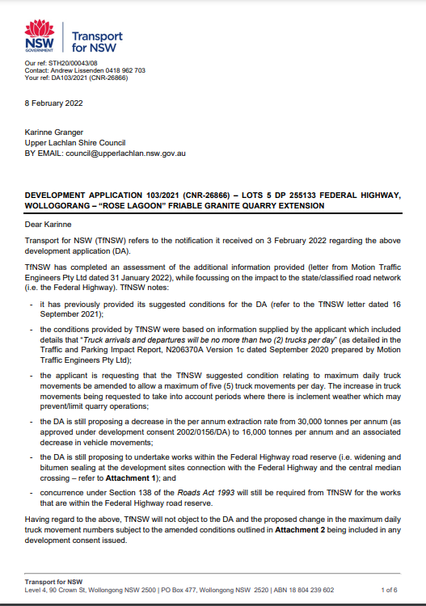
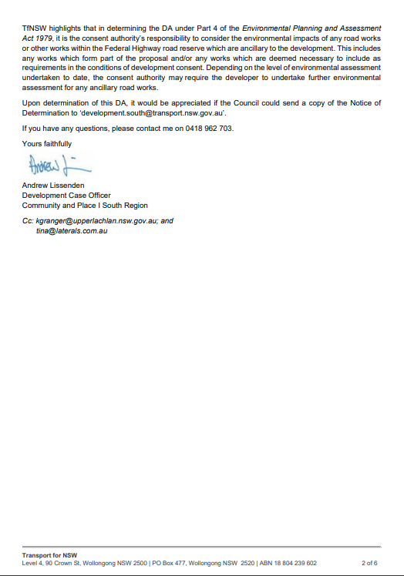

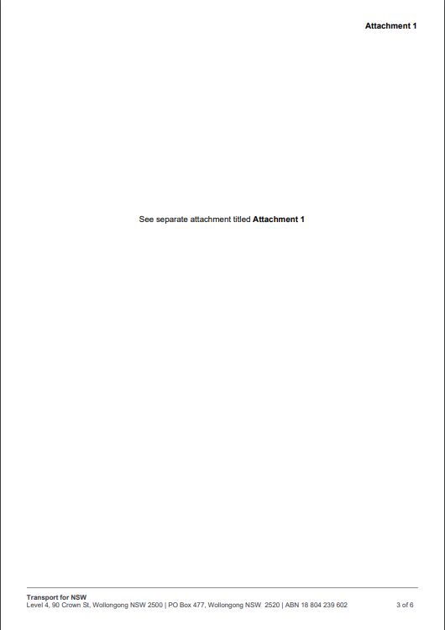

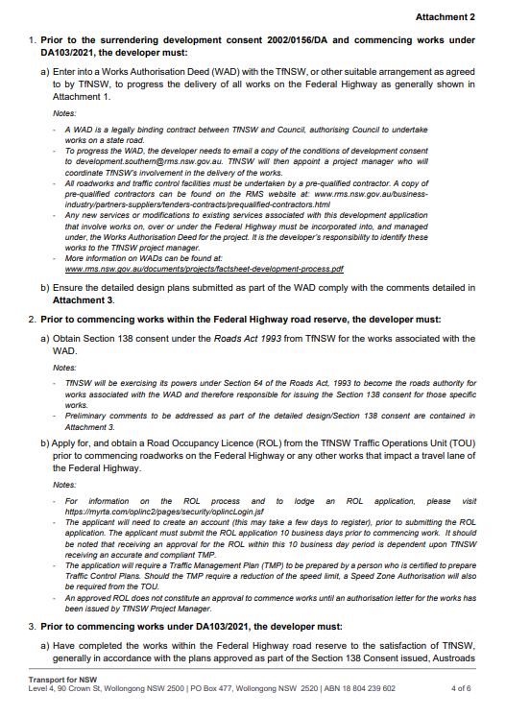

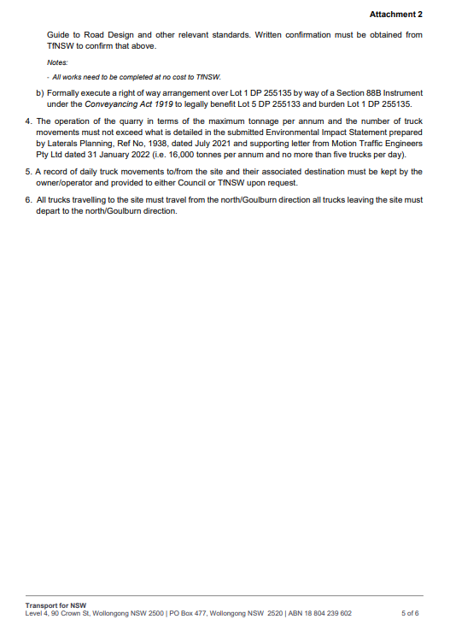

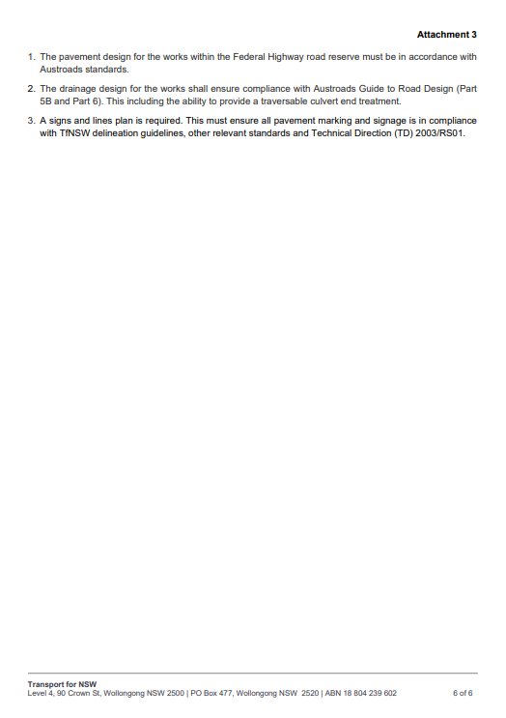

ADDITIONAL NOTES
Construction Certificate
Where construction work is proposed development consent is the first step. Before construction commences, a Construction Certificate must be obtained from Council or an accredited certifier.
Lapsing of Development Consent
Development consent does not lapse if the approved use has actually commenced or the proposed work is physically commenced before the consent lapse date, except where a condition specifies a limit to the duration of the consent.
Planning Assessment Commission
The Independent Planning Commission has not conducted a public hearing in respect of the subject development application.
Right of Appeal
If you are the applicant:
You can appeal against this decision in the Land and Environment Court within six (6) months after the date the applicant received this notice (Section(s) 8.7 & 8.10 of the Environmental Planning and Assessment Act, 1979). You cannot appeal, however, in the case of designated development determined by the consent authority after a public hearing held by the Planning Assessment Commission.
Review
An applicant may request the Council to review this determination within six (6) months after the date the applicant received this notice. The prescribed fee must be paid with the request for a review. Once the review is completed the Council may confirm or change the determination.
If there is an appeal, the period of time within which Council may undertake a review is extended up to the time the Court hands down its decision.
Notes:
A Review cannot be requested for:
- a determination to issue or refuse to issue a complying development certificate, or
- a determination in respect of designated development, or
- a determination in respect of integrated development, or
- a determination in respect of integrated development, or a determination made by Council under Division 4 in respect of an application by the Crown.
- a determination in which a regional panel exercises a Council’s functions as the consent authority.
Charges
Charges are reviewed each financial year. Any charges payable for this consent should be confirmed prior to payment. A copy of Council’s fees and charges is available free of charge at the Council offices.

Dial Before You Dig
Underground assets may assist in the area that is subject to your application. In the interest of health & safety and in order to protect damage to third party assets please contact Dial Before You Dig at www.1100.com.au or telephone on 1100 before excavating or erecting structures (this is the law in NSW). If alterations are required to the configuration, size, form or design of the development upon contacting the Dial Before You Dig service, an amendment to the development consent (or a new development application) may be necessary. Individuals owe asset owners a duty of care that must be observed when working in the vicinity of plant or assets. It is the individual’s responsibility to anticipate and request the nominal location of plant or assets on the relevant property via contacting the Dial Before You Dig service in advance of any construction or planning activities.

Telecommunications Act 1997 (Commonwealth)
Telstra (and its authorised contractors) are the only companies that are permitted to conduct works on Telstra’s network and assets. Any person interfering with a facility or installation owned by Telstra is committing an offence under the Criminal Code Act 1995 (Cth) and is liable for prosecution.
Furthermore, damage to Telstra’s infrastructure may result in interruption to the provision of essential services and significant costs. If you are aware of any works or proposed works which may affect or impact on Telstra’s assets in any way, you are required to contact: Telstra’s Network Integrity Team on Phone Number 1800810443.

